# Lab: Single Page Application

Problems for exercises and homework for the ["JavaScript Apps" course @ SoftUni.](https://softuni.bg/trainings/3589/js-applications-february-2022)

**Working with Remote Data**

For the solution of some of the following tasks, you will need to use an up-to-date version of the **local REST service**, provided in the lesson’s resources archive. You can [read the documentation here](https://github.com/softuni-practice-server/softuni-practice-server).

## Simple Calendar

## Calendar

Write a program that navigates through different views on a calendar, depending on your choice. You will be given HTML and CSS code with the views for different years along with their months and days.

### Screenshots

Year selection view – contains a list of years. Clicking the desired year should display the view, containing the months for that year.

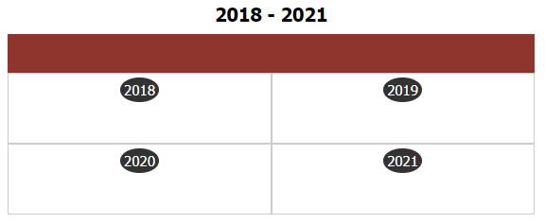

Yearly view – contains a list of months for the selected year. Clicking on any of the months should switch to the monthly view. Clicking the year (top part of the table) while in the yearly view returns the user to the list of years.

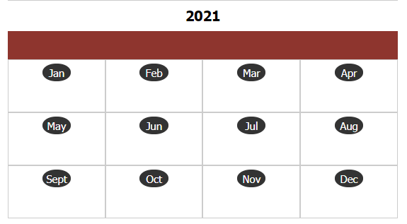

Monthly view – contains a calendar with all dates for the selected month, arranged as weekdays. Clicking the month (top part of the table) while in the monthly view returns the user to the list of months.

